**Understanding Scrum**

10- In scrum teams, the team members can plan their own work

ANS- C): True, as long as their work is related to the stories in the PB

12- The PO estimates the effort needed to complete the stories in the sprint

ANS- False

14- If you don’t have a cross-fucntional team ( where team members have multiple skills like development, testing etc) you cannot start a project using Agile

ANS- False

**History of Scrum – Slide 3**

Takeuchi and Nonaka

Ken Schwaber and Jeff Sutherland 1993

In use at many Fortune 100 companies globally

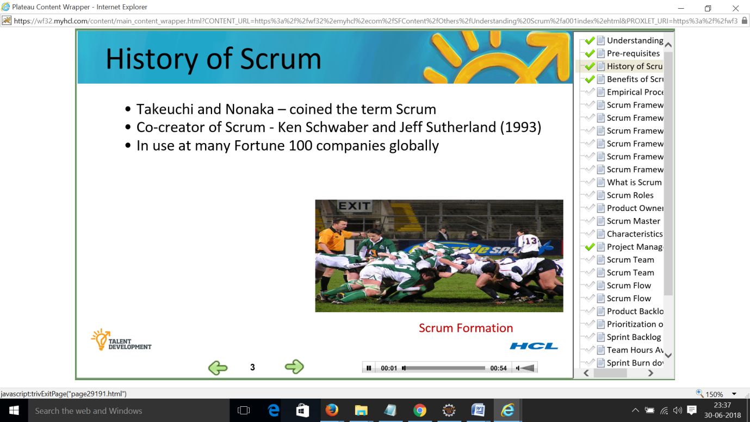

**Benefits of Scrum - Slide 4**

Adapting to changing business requirements

Achieving faster ROI

More transparency for business

Enhanced communication and trust between business

and IT

Reduced development risk with phased integration and continuous user feedback

Provide greater visibility and minimise surprises through continuous delivery

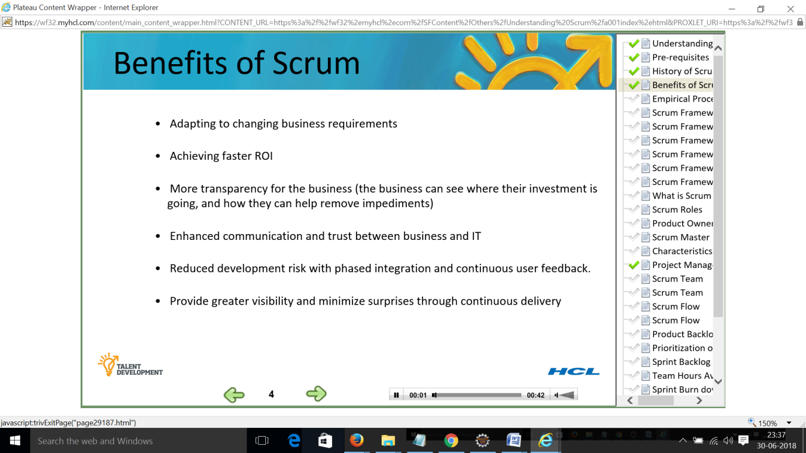

**Empirical Process Control – Slide 5**

Paper by Takeanchi and Nanaka

Technology x axis and requirement y axis Blue areas – these factors are increasing complexity

All those projects falling in that category adopt scrum - Address complexity and reduce risk

Dimensions of complexity in software development involving requirements, technology and people

To overcome complexity scrum implements

Improved visibility, frequent Inspection and Adaptation to new circumstances

Scrum implements the above rules with simple set of practices and rules

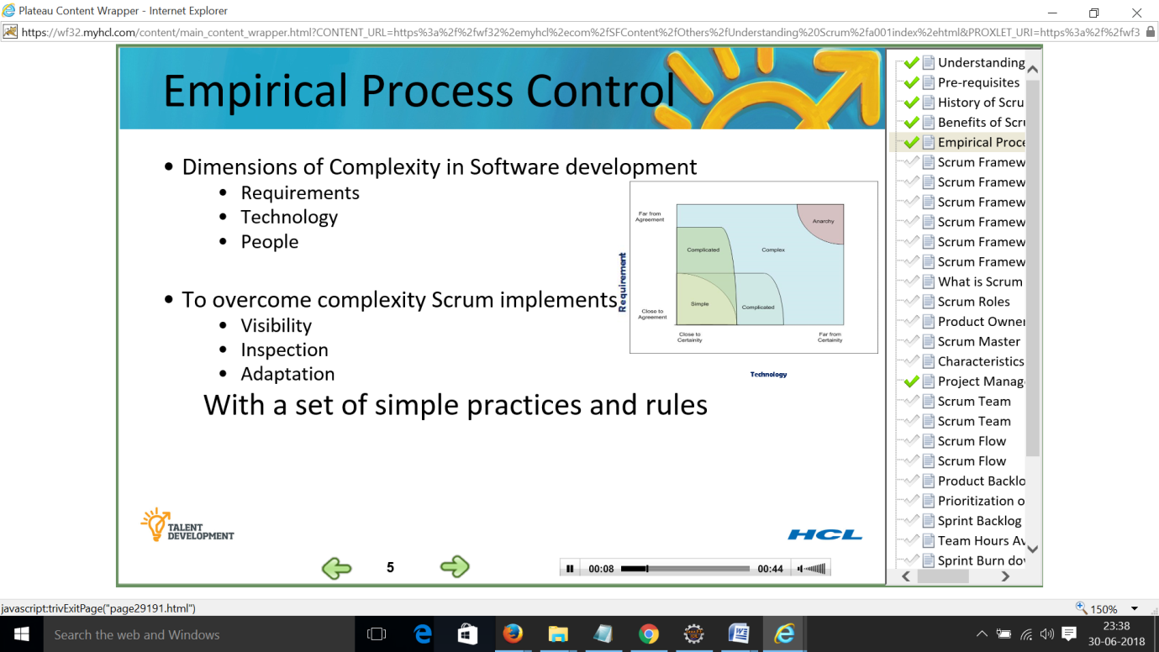

**Scrum Framework – Slide 6**

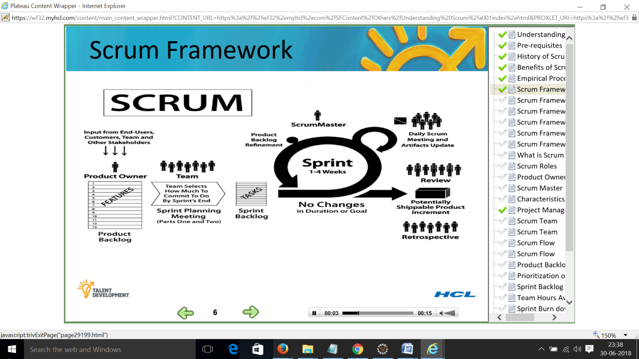

**Scrum Framework – Slide 7 – Product Backlog**

SCRUM is a SDLC methodology

Excel sheet where every row is a requirement or user story agile term for requirements

Product backlog – Story in row 1 higher priority than story in row 13

Product owner is creator and sole contact for anything that comes in or moves out of product backlog

Product owner takes in the input from end users, customers, team and other stake holders

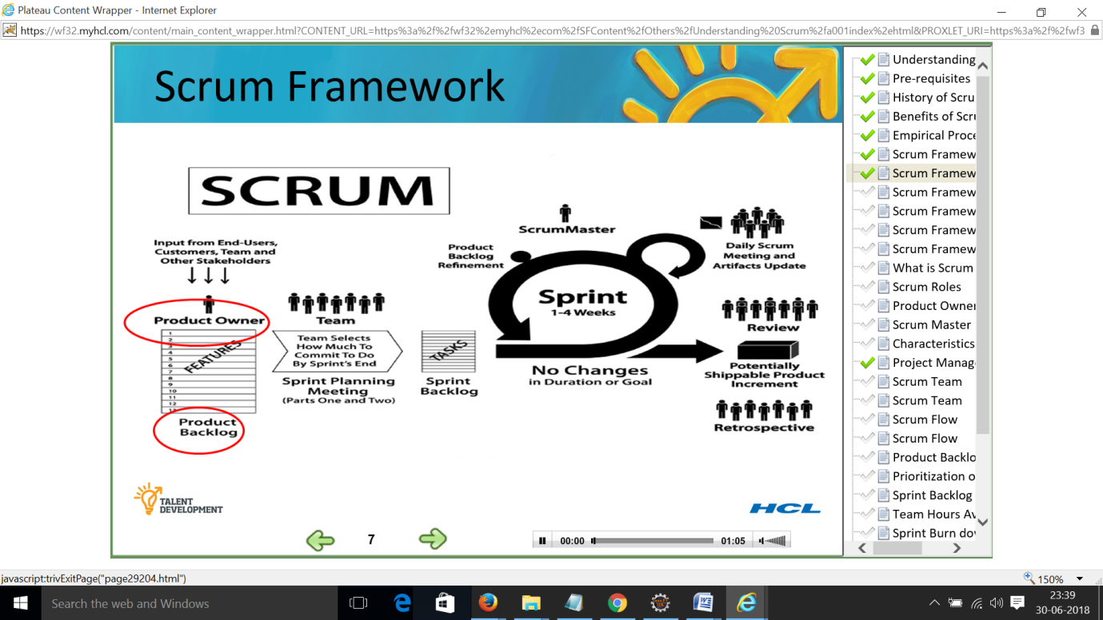

**Scrum Framework – Slide 8 – Sprint planning meeting**

Once product backlog is ready and stories for the sprint have been identified, Scrum team gets into a meeting called - sprint planning meeting –

Sprint planning meeting is split into two parts - Part one and part two

Part One - Story for the meeting is planned is picked and discussed in detail by the team

All members need to be present as part of the meeting

Product owner provides clarification to the team from requirements perspective.

Job of scrum team is to understand, cross question the PO and scrum Master if needed

At end of part one – requirements must be clearly understood.

And acceptance criteria should be clearly articulated.

Acceptance criteria is key input against developer will write their code and testers will test against

Part two – Each of the story requirements and user stories selected are broken down into tasks. Development and testing related tasks. Each task is associated with effort, with person who is going to execute the task.

All these tasks are captured in excel or other agreed tools like JIRA

Once the meeting is over the sprint starts and team should only be working on the stories that are in the sprint.

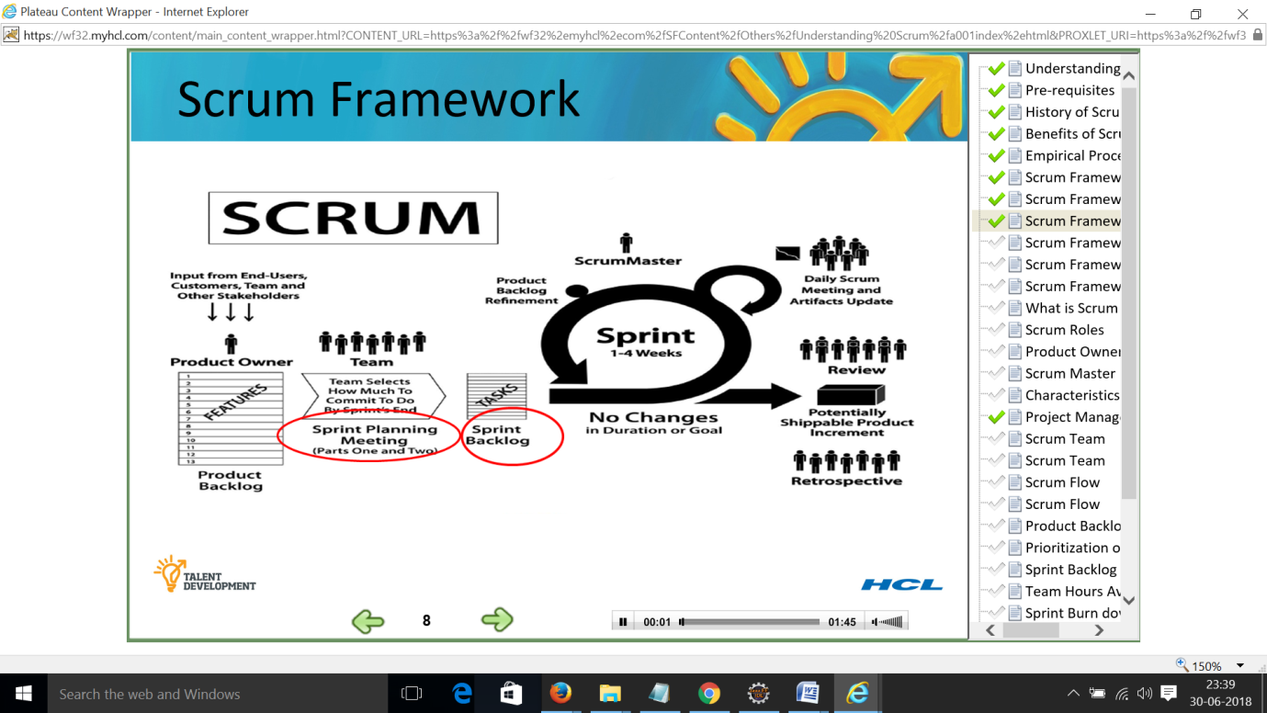

**Scrum Framework – Slide 9 – Sprint**

Scrum recommends that sprint duration is between one to four weeks

Very important to note that duration once decided, duration will remain consistent all through the project

At any point if the stories or tasks for the sprint are unable to complete,duration will not change, rather the scope is changed and unfinished story is moved to the product backlog

PO is supposed to reprioritize the same

Once sprint starts, there should not be any major changes to the goal of sprint stories or tasks. If there are major changes the sprint be dropped and new sprint need to be started.

Planning activity needs to happen at time when team members are available. For the teams that are distributed, this needs to be taken care.

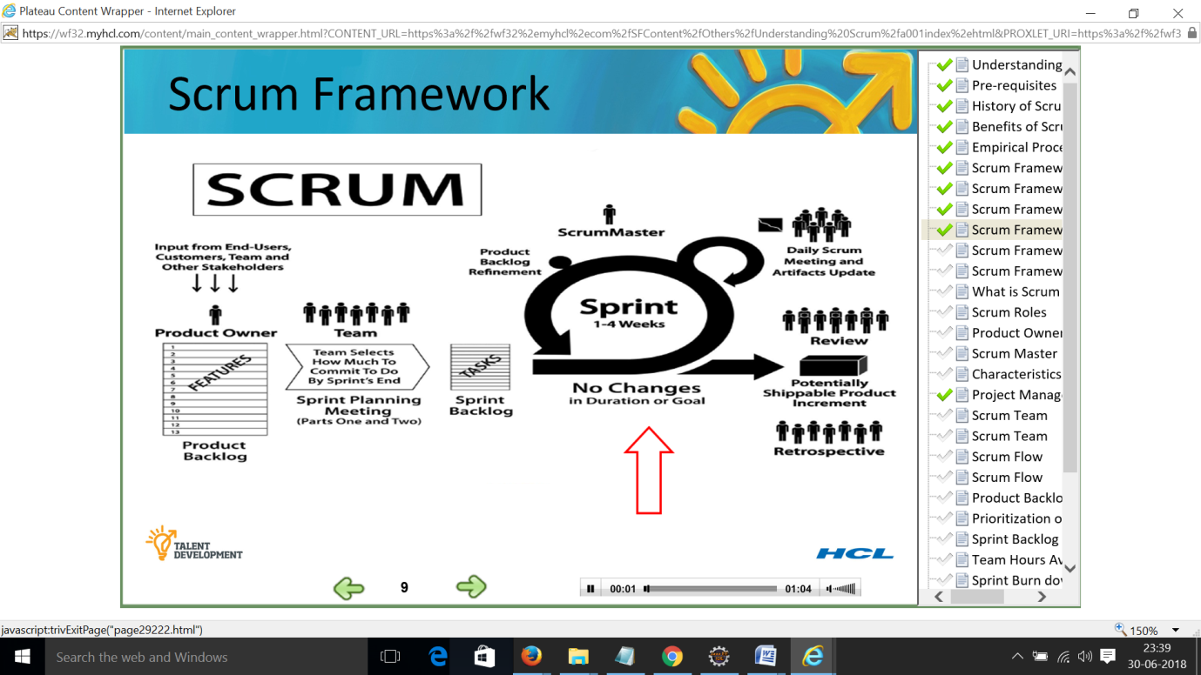

**Scrum Framework – Slide 10 – Daily stand up meeting**

Once sprint starts, the tracking of the sprint also starts.

This is done using ceremony called as the daily stand up meeting.

This should happen same time and same place on every working day

In this meeting, all the team members tell the status to the entire team by answering three questions

Three questions – 1. What I have done since last week regarding this project

2. What will I do before next scrum meeting?

3. What impedes me from performing my work effectively and what are the blockers – it is the job of Scrum master

BA is responsible for grooming product backlog refinement

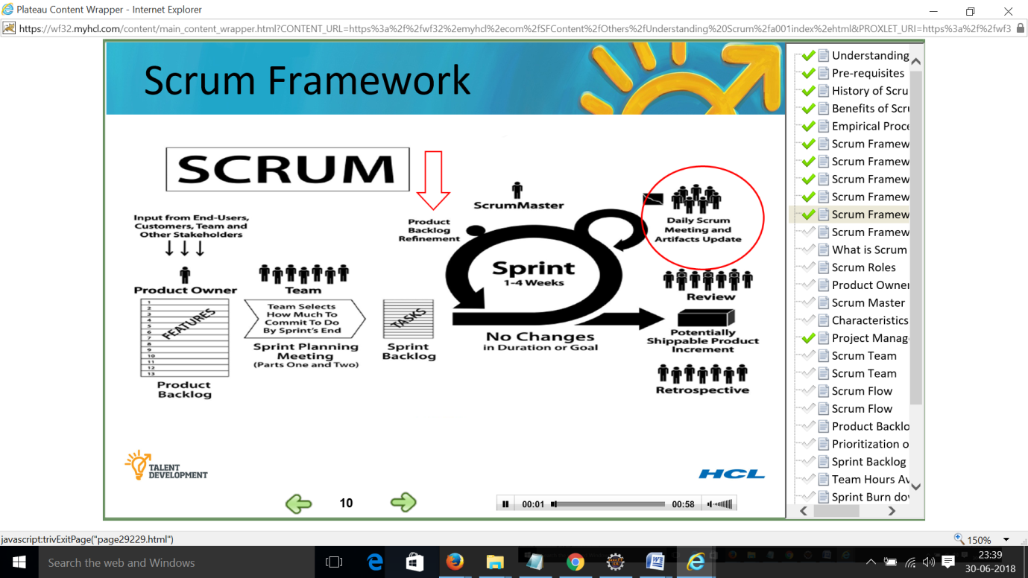

**Scrum Framework – Slide 11 – Review and Retrospective**

Every sprint ends with a review.

This is meeting where all the stake holders come and watch the team demonstrate what they have achieved in the sprint

This is demo of working software usually done from QA environment also referred as show and tell

This is time for stake holders to give feedback to the team; Based on feedback the team can give any coarse correction needed for the next sprint.

Last meeting – Retrospective

Gives objective feedback on What went well, What did not go well, things to escalate and things to try. This is also fed back into the planning meeting next sprint.

Sprint planning, review and retrospective occur once every sprint.

What comes out is potentially shippable software which can be deployed to production if there is a need to do so.

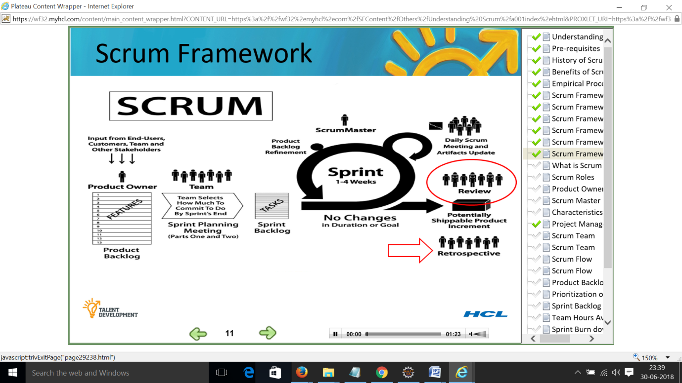

**What is Scrum– Slide 12**

Most important part is that scrum is not a prescriptive process it doesn’t describe what to do in every circumstance

Need to create document so that the knowledge is retained to the client after the project gets over

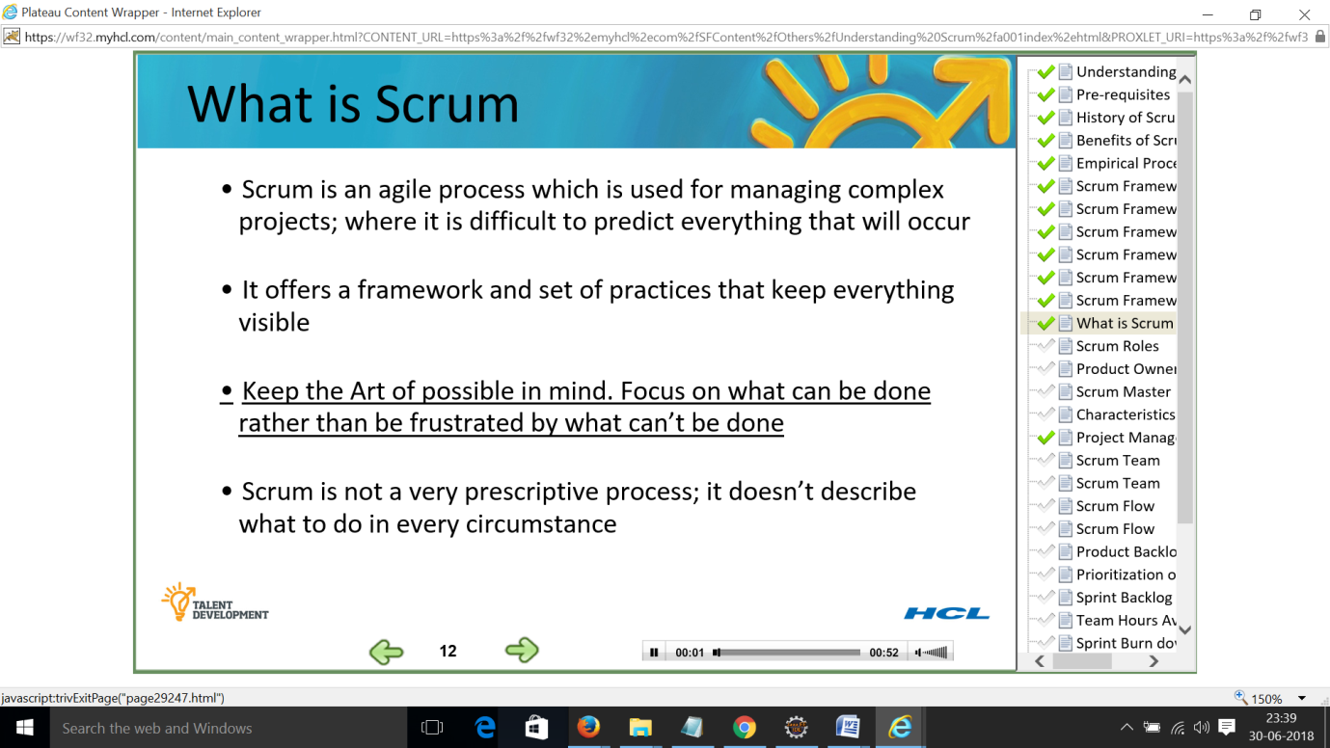

**Scrum Roles – Slide 13 – Scrum Roles**

Scrum advocates only three roles –

First role - The product owner

Should ideally from client side where he can take decision related to product backlog

Second role - The scrum master

Is from vendor side because he is better equipped to handle day to day issues of team

Its better if scrum master is co located with the team instead of client location.

Third role - The team

Composition of the team need to be as per the requirements of the project

Performance tester or SOA tester or specialist UI designerwhat ever the skills are needed the team needs to have it.

Other aspect is the team needs to be cross functional. Team needs to be mulit skilled to take up tasks for the other person.

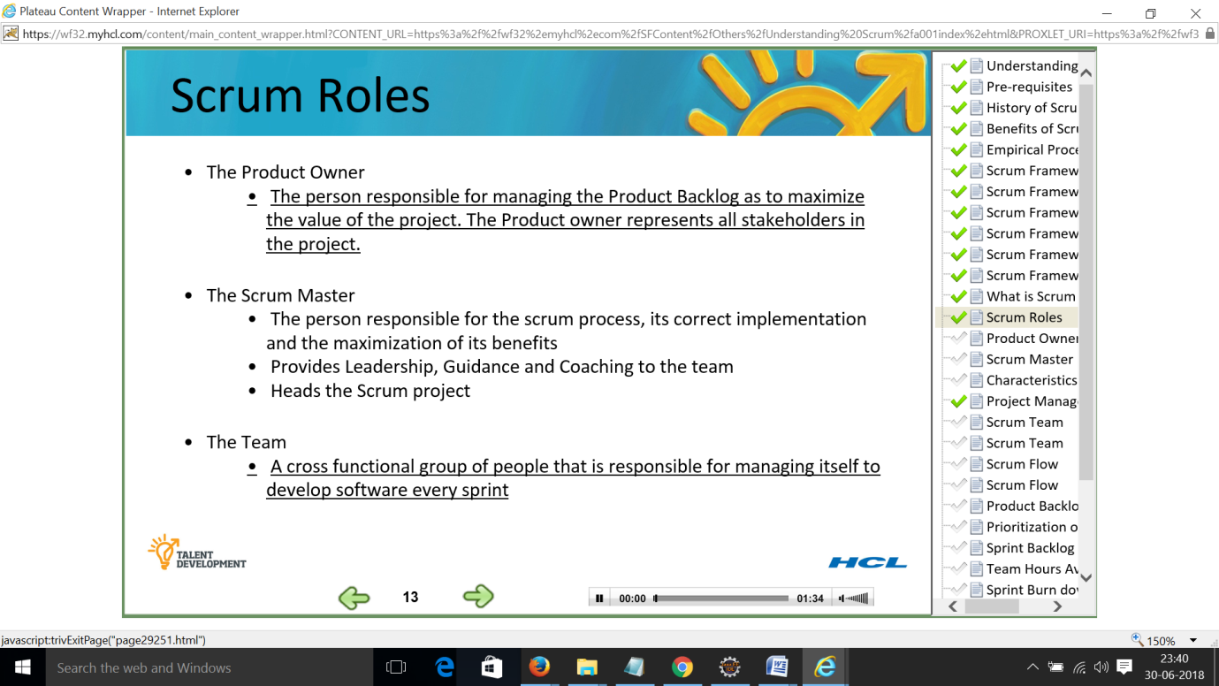

**Product Owner – Slide 14 – Product Owner**

Product owner is responsible for prioritizing the product backlog in such a way that it maximises the ROI for the organisation

Refines and reprioritize the product backlog as per the needs from sprint to sprint

Participates in sprint planning and sprint review meetings and provides support to the team as required

Product owner is responsible for participating in the estimation meeting to provide answers and clarifications for the stories.

Final decision maker on Product backlog

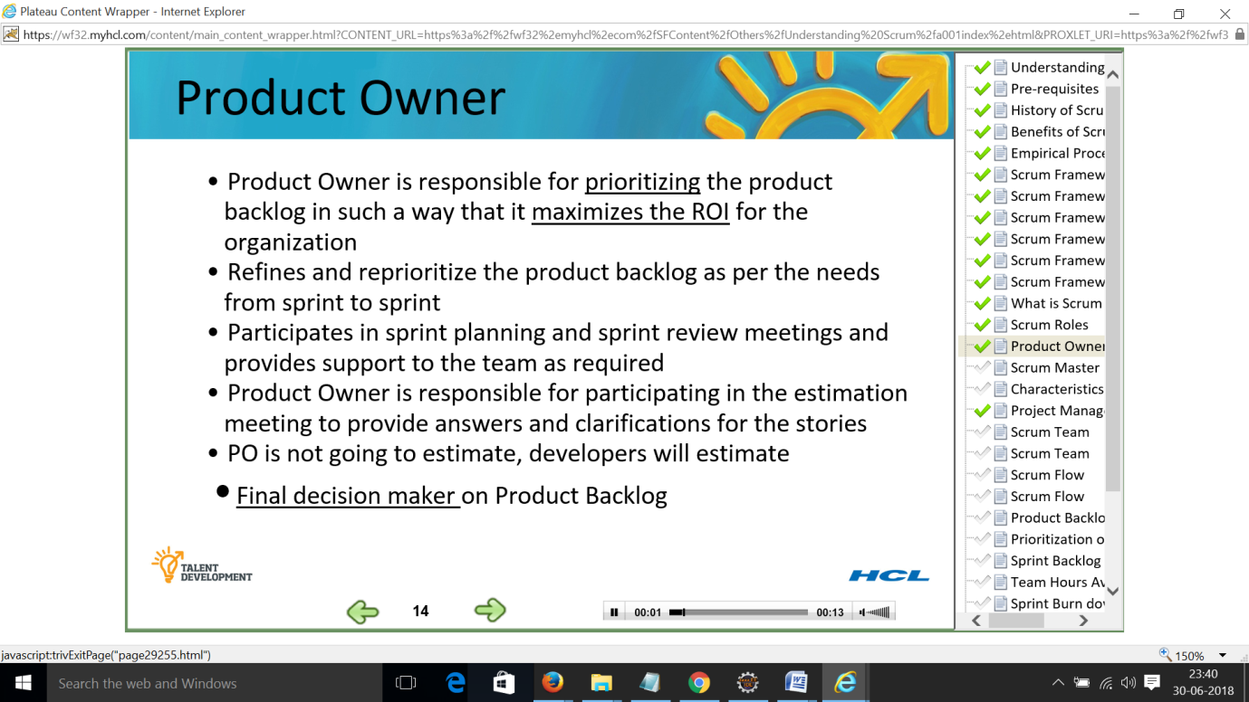

**Scrum Master – Slide 15**

Scrum master helps the team in removing the obstacles and impediments to the progress of the project.

Protects the team from outside disruption and threats

Teaches scrum to the team product owner and company management

Ensures that standard practices of scrum are followed

Communicates with product owner

Facilitates daily scrum meetings

Keeps information about the team’s progress up-to-date and visible to all parties

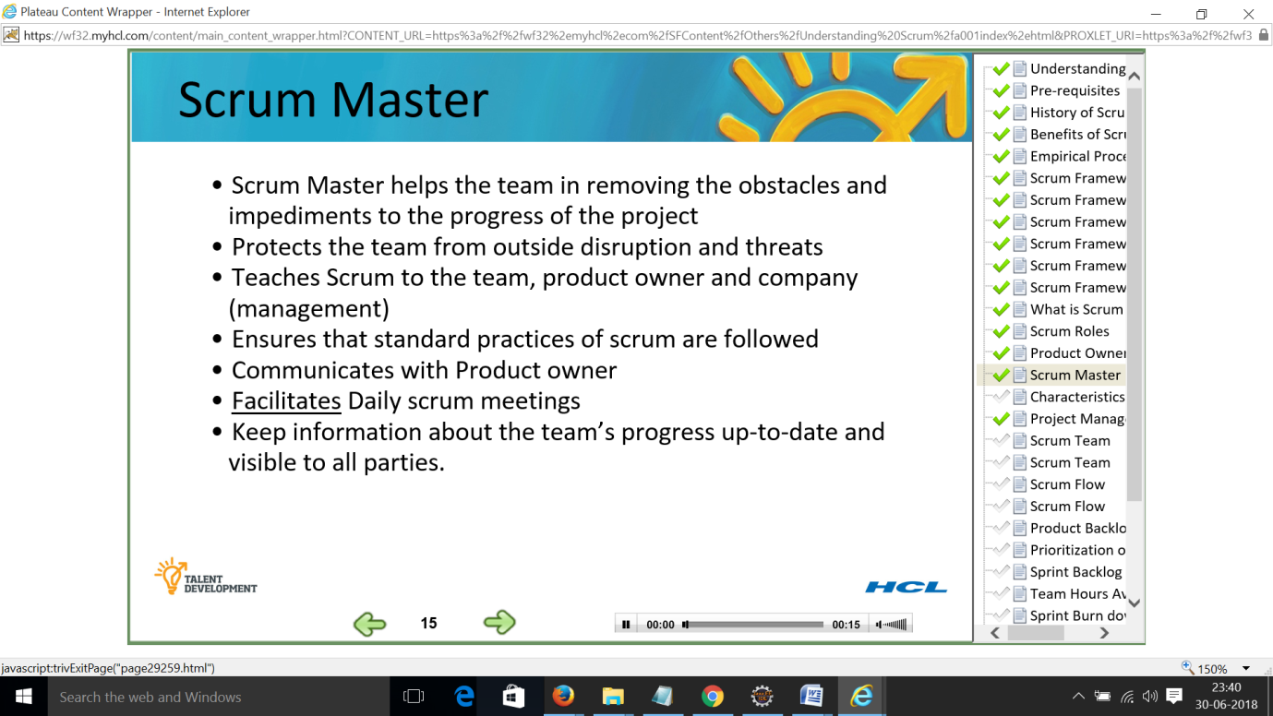

**Characteristics of a Scrum Master – Slide 16**

Good inter personal skills

Good communication skills

Proactive, helpful

Good listener

Good observer

Courageous mindset

Committed to the success of the team

May or may not possess technical expertise

Avoid having team’s manager as scrum master

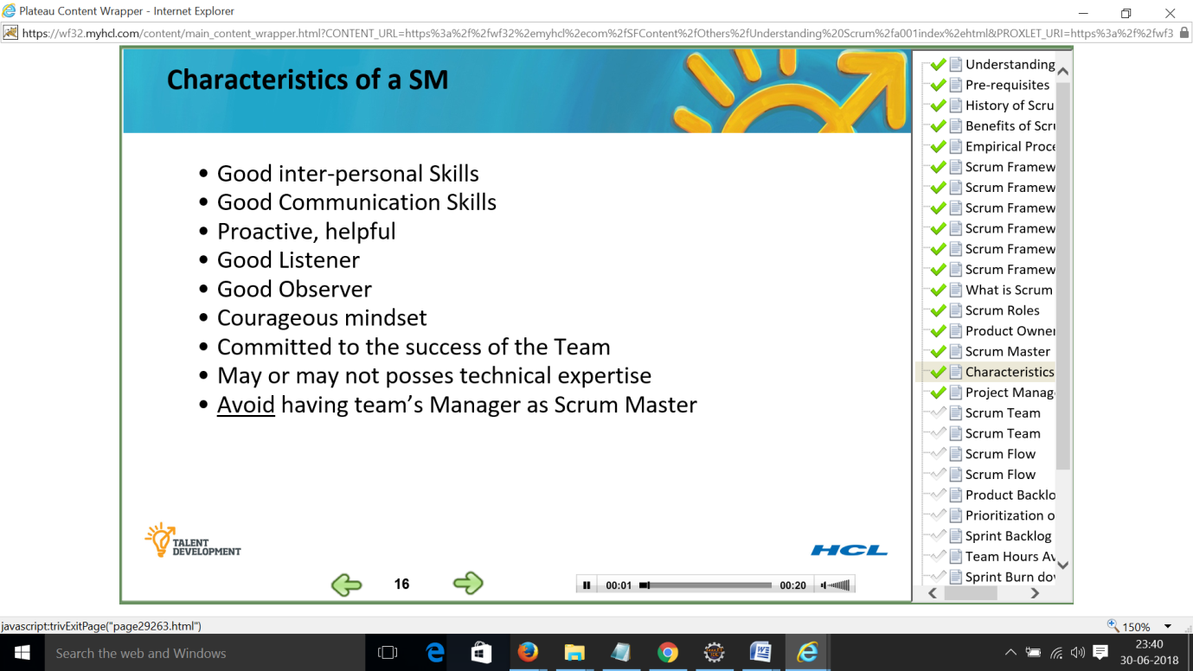

**Project Manager vs Scrum Master – Slide 17**

Scrum master is not the boss of the team

Scrum master does not assign tasks to the team

Scrum master does not make decision for the team

Scrum master is not responsible for the team getting their work on time

The team is responsible for the above mentioned activities

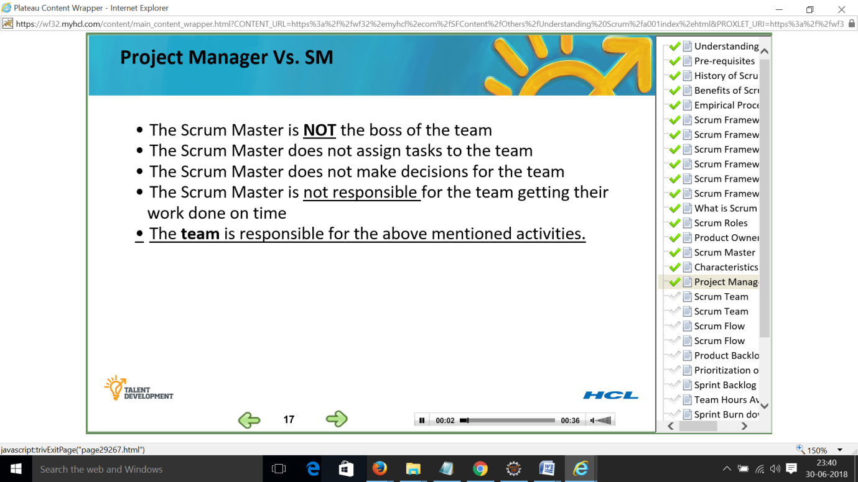

**Scrum Team – Slide 18**

7 people

Cross functional – developers, testers, UI designers, BA, technical writers, etc.

Self organising and self managing – everyone commits to ALL TASKS necessary during the sprint

Teams have a velocity

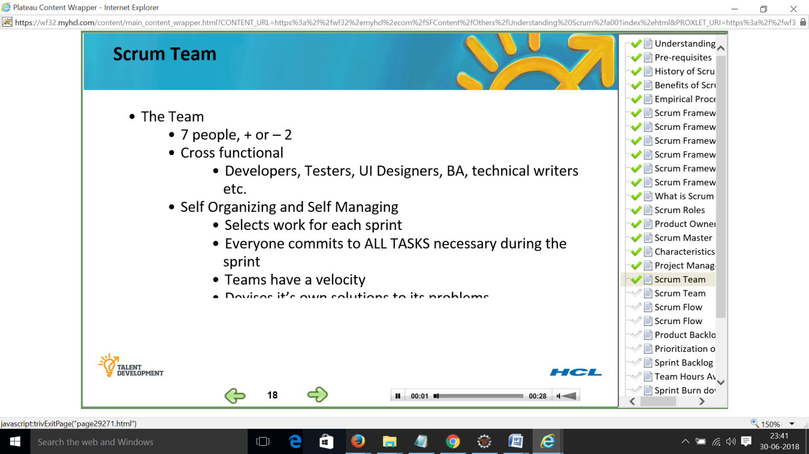

**Scrum Team – Slide 19**

Have focussed goals that are aligned with a company’s strategey

Use truth and transparency to establish trust on your teams

Peer accountability will evolve

Constantly revisit and revise your processes to improves quality quantity and transparency

Empower teams to self manager giving them the means and authority to remove discovered obstacles.

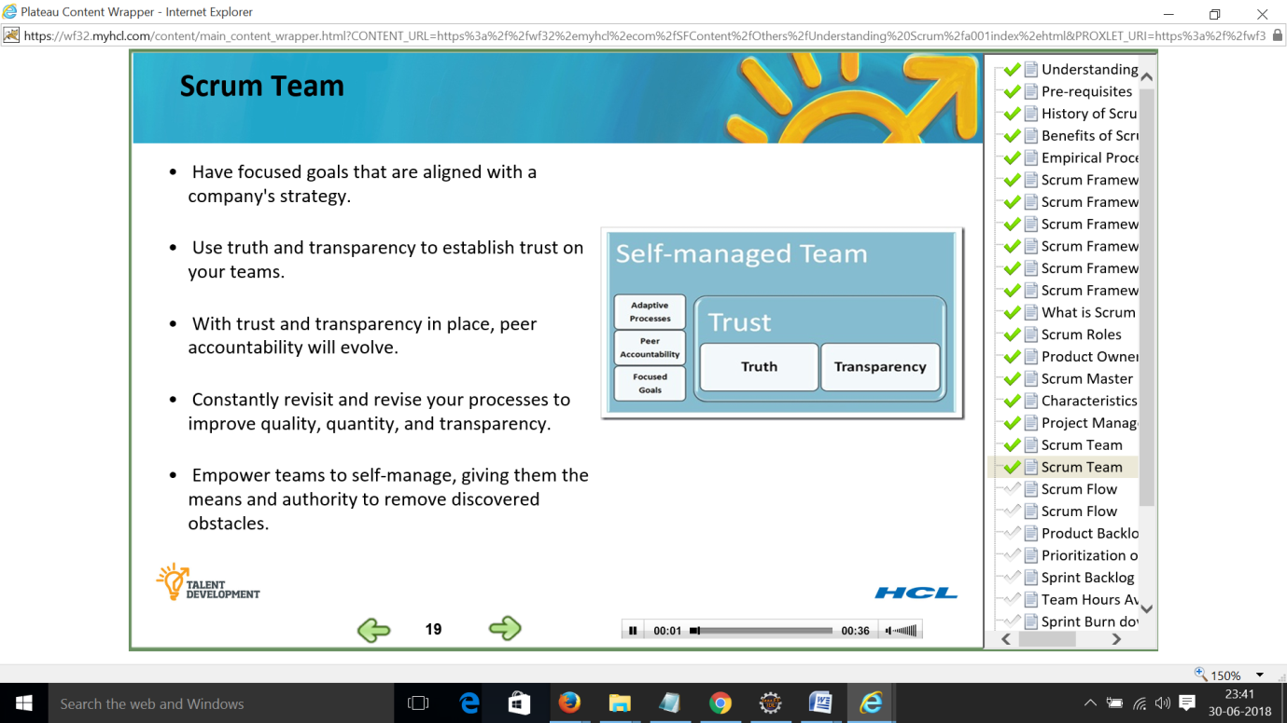

**Scrum Flow – Slide 20**

Vision of the system

Preparation of product backlog – functional requirements and non functional requirements

Sprint planning meeting – maximum 4 hours for two week sprint

Initial two hours – Product owner presents highest priority product backlog to team

Team questions PO for content, purpose, meaning and intentions of the product backlog

Team selects from the product backlog and commits on what it can deliver in the coming sprint

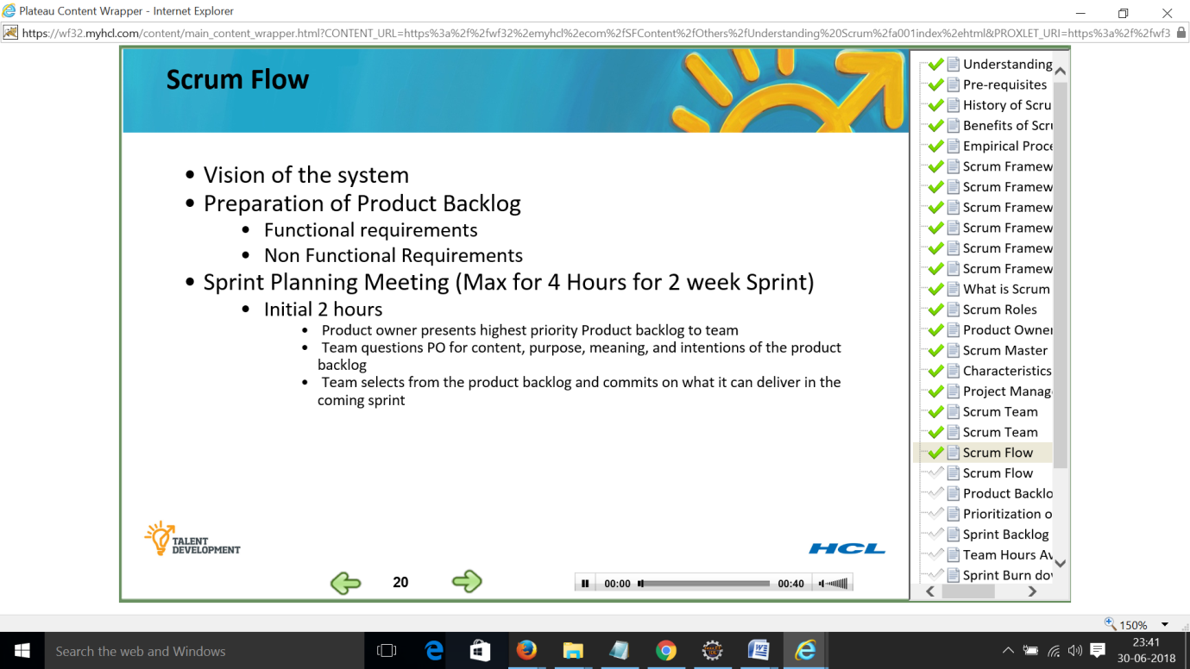

**Scrum Flow – Slide 21**

Sprint planning meeting

Next two hours –

Team plans out the sprint.

The tasks selected are placed in the sprint backlog

At the start of these two hours sprint has started and clock is ticking for the 30 day sprint time box

Daily scrum – daily team stand ups for 15 minutes

Sprintreview meeting – max. For two hours

Team presents what was developed to the product owner and other stake holders who want to attend

Sprint retrospective meeting – what went well, what didn’t go well, thnigns to try, things to escalate

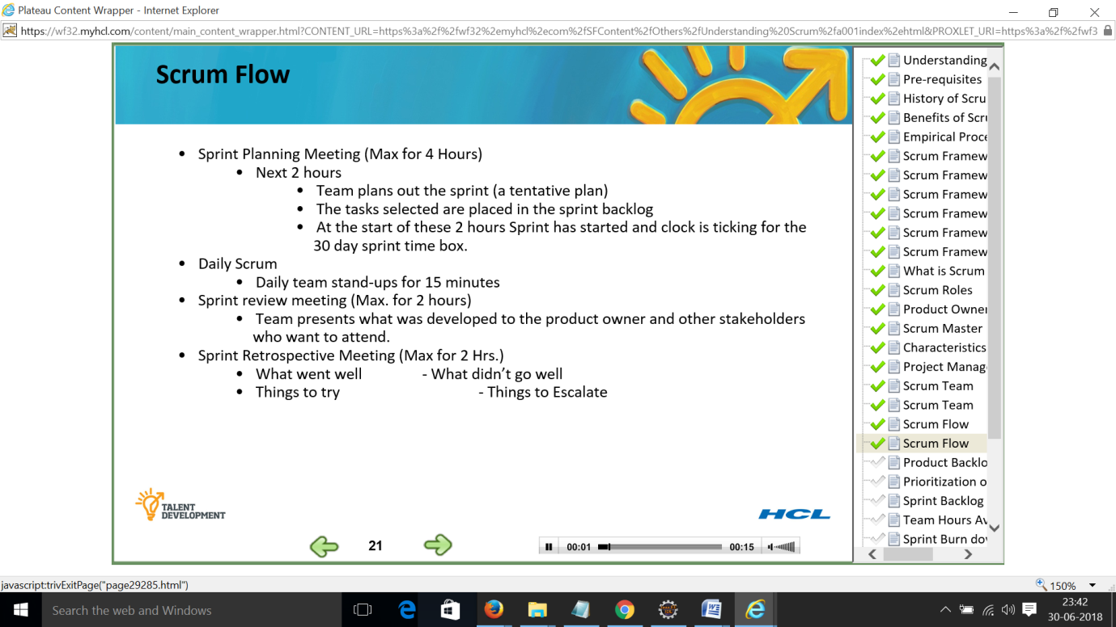

**Product Backlog – Slide 22**

Product backlog contains the requirements for the system

The PO is responsible for product backlog

Product backlog is not frozen but evolves over time

Management constantly changes it to identify what the product needs to be appropriate,

Competitive and useful

User stories are a good approach to write a product backlog items

No one should be working on anything that is not a product backlog.

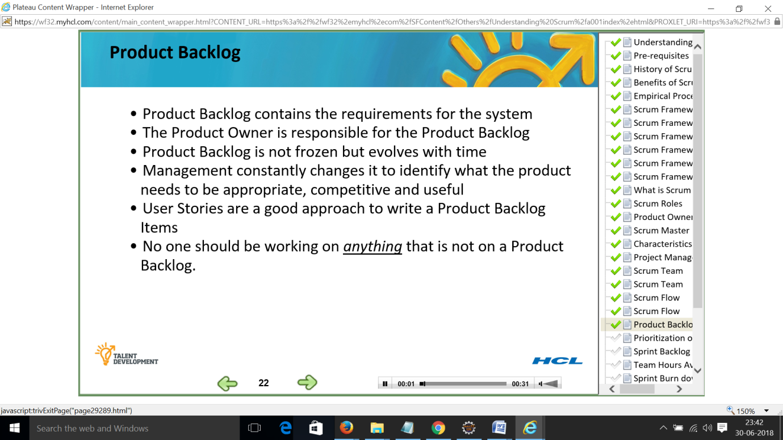

**Prioritization of Product Backlog – Slide 23**

Items in the product backlog are maintained and prioritized by the product owner

High priority stories are at the top of the product backlog

Stories at the top are described in full detail

Detailing of stories are done for up to two future sprints

Stories down the line may be defined in less detail

Stories at the end may only be statements of wish list

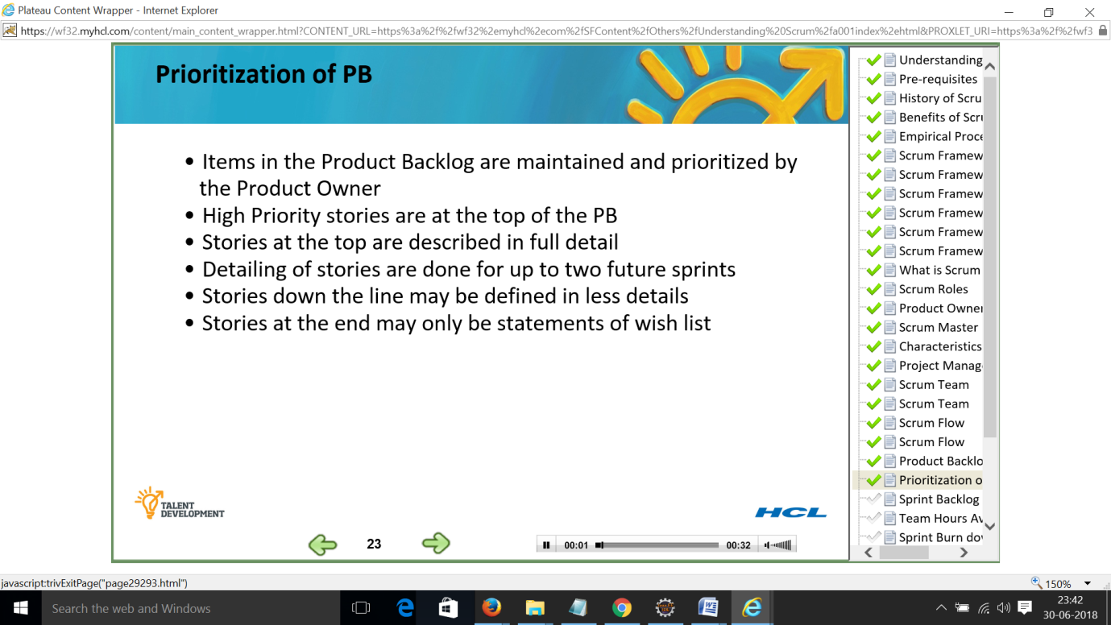

**Sprint Backlog – Slide 24**

Sprint backlog defines the work or tasks for the current sprint

Tasks are divided such that each task takes roughly 4 to 8 hours

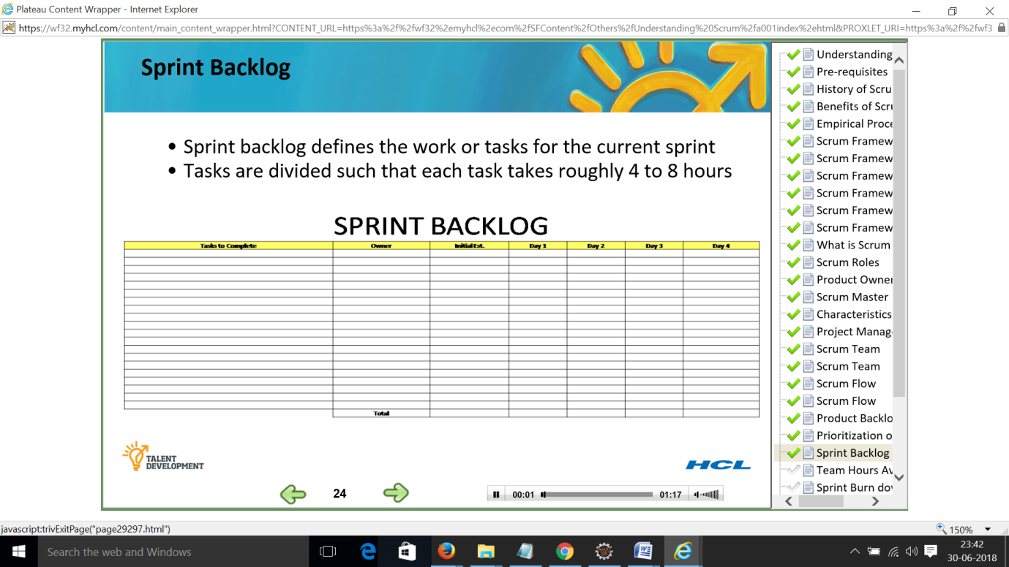

**Team hours available – Slide 25**

Sprint backlogs has lists of tasks that have efforts against them

8 people working in a project for 8 hours a day is 64 hours per day and for 10 day work sprint is 640 hours per week

People should plan only 80 to 85 percent of days work as productive work.

7.5 hours as productive hours fro a 9.5 hour day

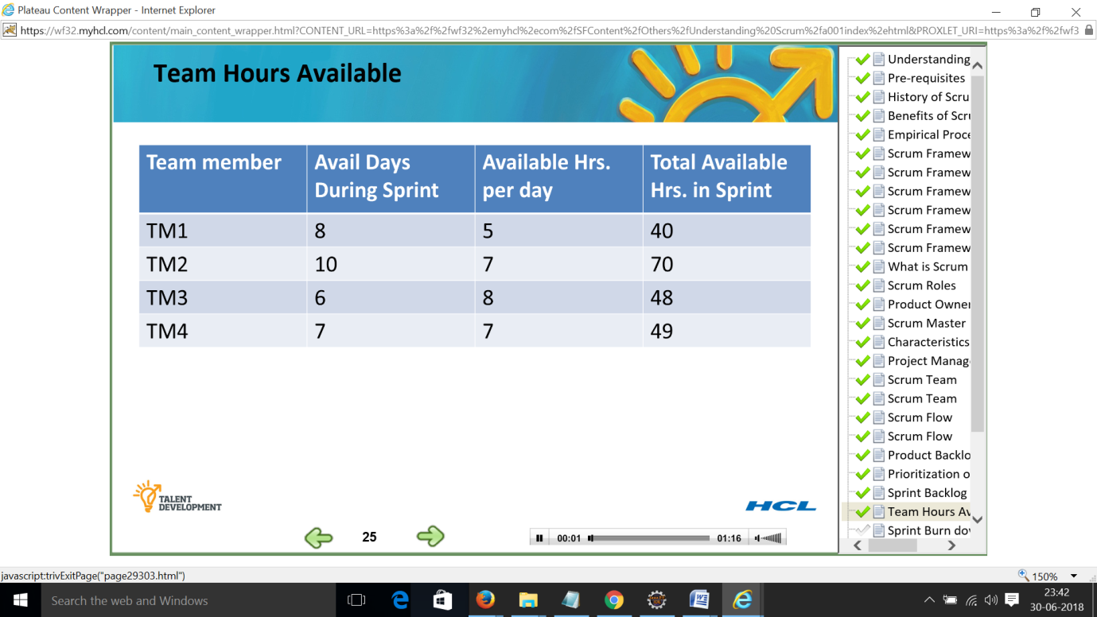

**Sprint burn down – Slide 26**

Sprint burn down is the most important project tracking tool

Pause for a moment to understand that this is one of most powerful tools in scrum

At any point of time it shows the work remaining to be completed in the sprint

90 hours on day 1 of sprint – blue line represents the ideal line that will reach zero hours on day 10

red line reflects the daily status

Day 1, Day 2 and Day 3 – ahead of their planned work

Day 5, Day 6 and Day 7 –team fell behind

Day 8, Day 9 and Day 10 – team need to pull their socks up to meet their deadline, finishing on time

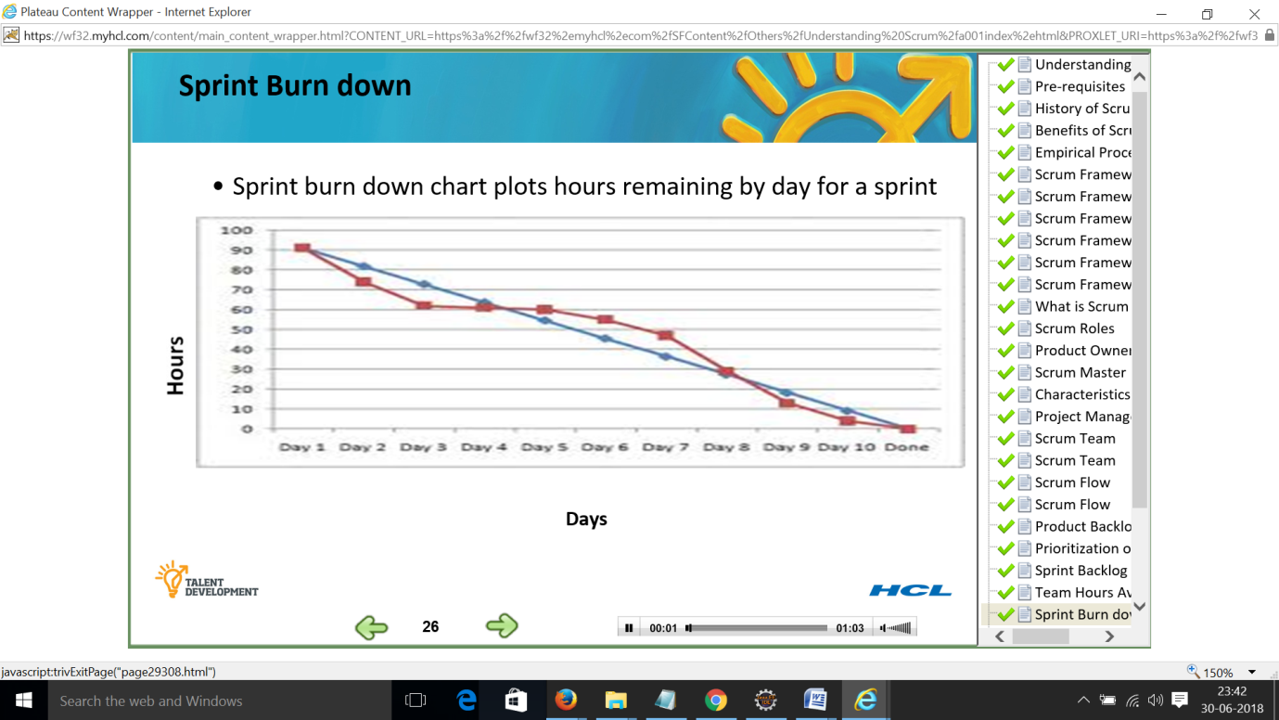

**Daily Scrum – Slide 27**

Time boxed to 15 minutes regardless of number of team members

Hold daily scrum – same time, same place every workday

Scrum master to start the meeting at the appointed time regardless of who is present

Each team member responds to three questions only

What have I done since last meeting regarding this project

What will I do before next scrum meeting

What impedes me from performing my work effectively

Team gives status to each other and NOT to scrum master

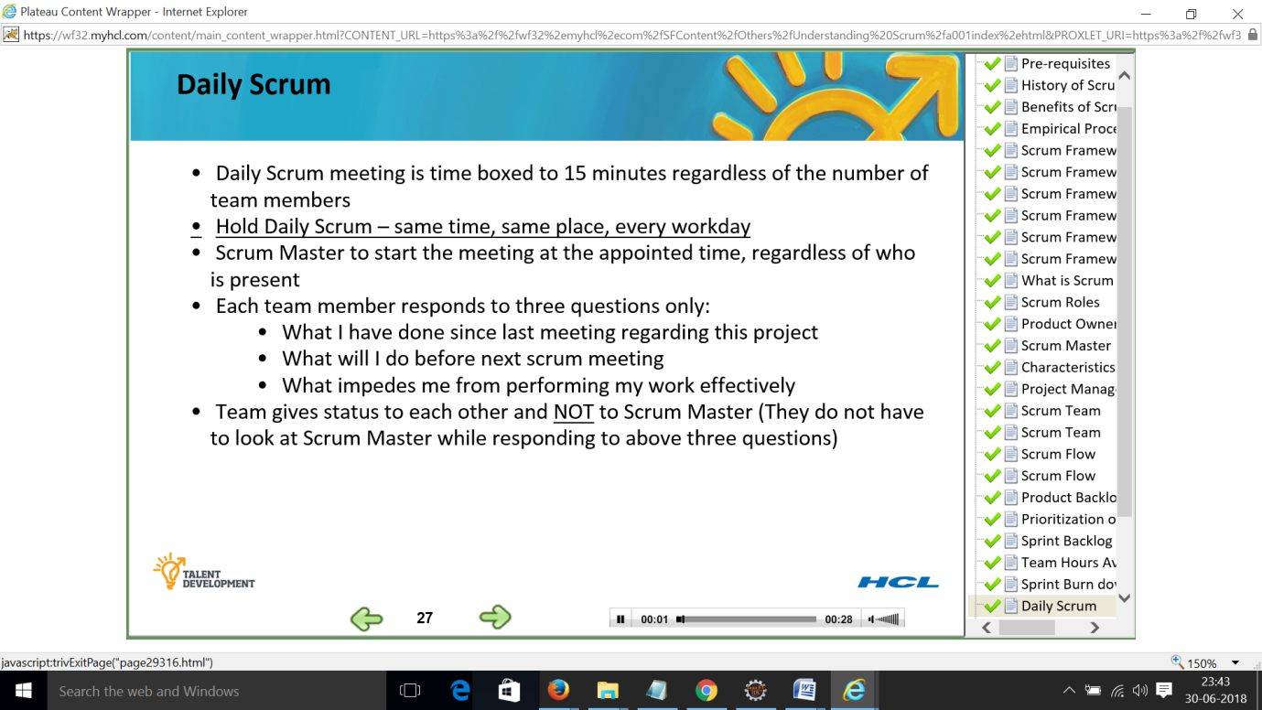

**Sprint Review – Slide 28**

Sprint review is used for demonstration or show and tell

Team shows working software to stake holders

Demonstration of working software is from a QA environment

Working software is the primary measure of progress

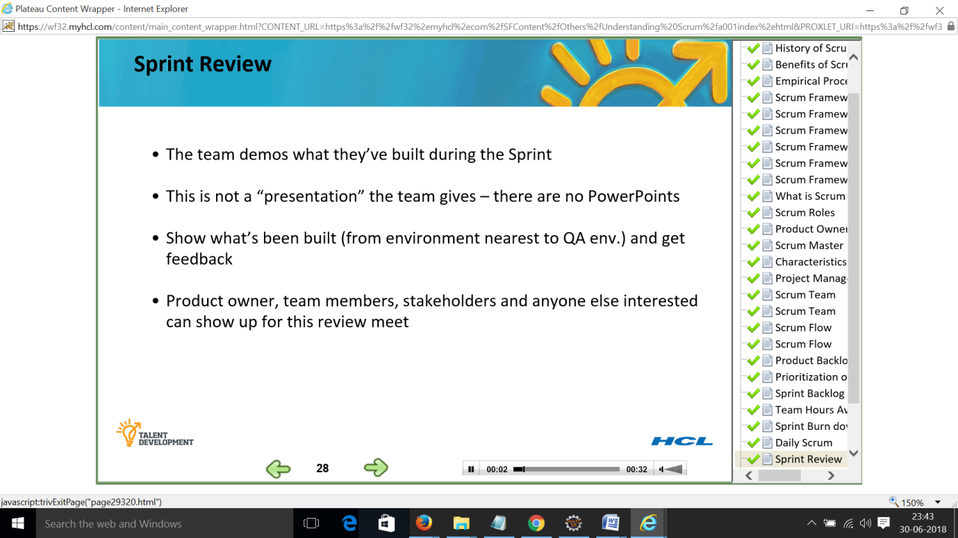

**Sprint Retrospection – Slide 29**

It is opportunity for the team to discuss what’s working and what is not working and agree on changes to try.

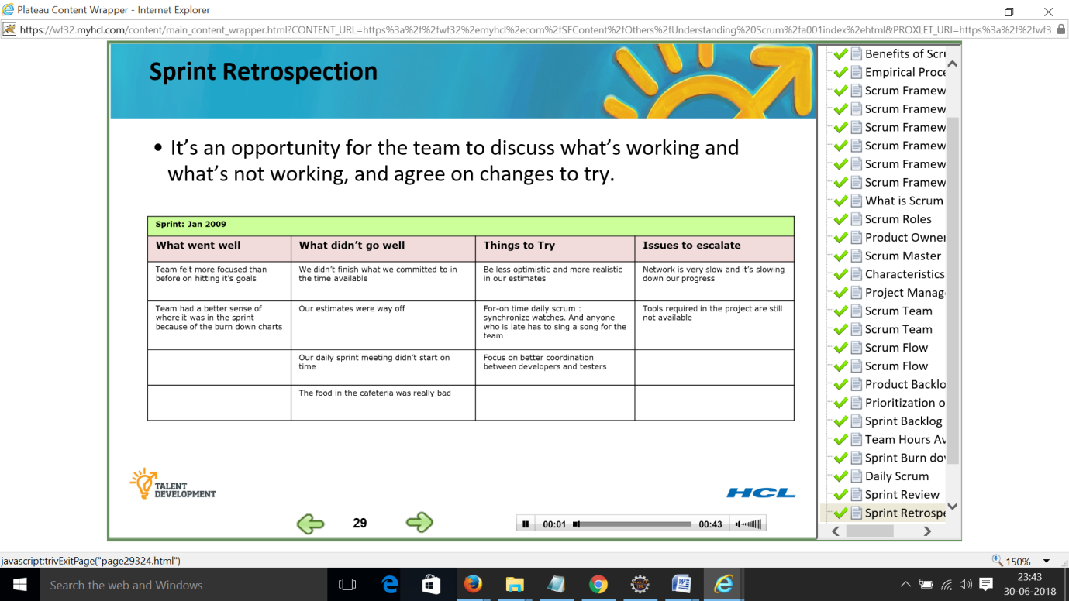

**Scrum in short – Slide 30**

Scrum roles – the product owner, the scrum master and the team

Scrum artefacts – product backlog, sprint backlog, burn down chart

Scrum ceremonies – Sprint planning, product backlog refinement, daily scrum, sprint review and retrospection

